Sellers Name: _____________________________________
Sellers Phone Number: ____________________________
Order/Money Turn-In Date: __Sunday Sept 27_____________
Delivery Date: _________Sunday Oct 11, before church__
Delivery Location: ______1st Lutheran social room_____

*Complete this form and give to Heather Quedenfeld at heather.quedenfeld@comcast.net or 724-263-3253 (email, call or text)
 | Name | Potato &  Cheese  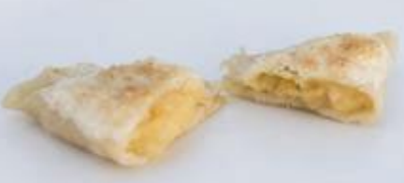  Our most popular pierogi, filled with potato and savory cheddar cheese. | Sweet  Cabbage  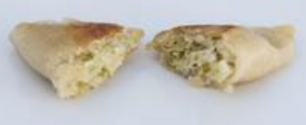  Just like Grandma’s Haluski wrapped up in a delicious pierogi. | Potato  & Feta  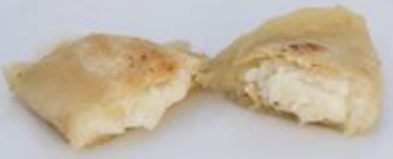  Switch it up with the more contemporary flavor of our potato and feta pierogi. | Sweet  Potato  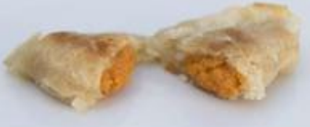  Add a Polish twist to your Thanksgiving tradition! Make it sweet with brown sugar & crushed pecans on top. | Sauerkraut  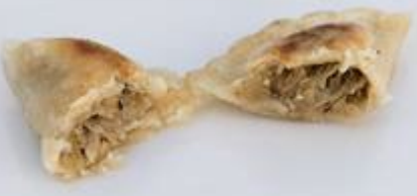  Stuffed with sauerkraut, this favorite has a traditional Polish flavor. | Cottage  Cheese  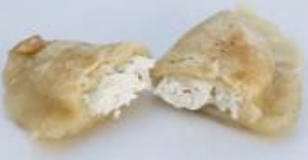  An exquisite mix of dry cottage cheese and chives. | QTY  (# of dozen) | Total  (QTY x $8)
1
2
3
4
5
6
7
8
9
10
11
12
13
 | Total
ALL PIEROGIES ARE FROZEN - $8.00 EACH – PACKAGED BY THE DOZEN. CASH or CHECKS Payable to: __First Lutheran Church___
Please make arrangements to pick up all orders on October 11th. All pierogies will be frozen. Consider bringing a cooler with you to keep the pierogies frozen until you can bring home.
Product should be frozen until ready to use to ensure safety and quality. PRODUCT IS PERISHABLE.

